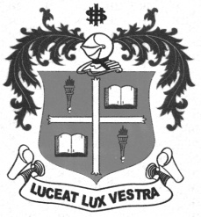
LOYOLA COLLEGE (AUTONOMOUS), CHENNAI – 600 034
B.A. DEGREE EXAMINATION – HISTORY
FIFTH SEMESTER – NOVEMBER 2012

HT 5402 - HISTORY OF CHENNAI

Date : 16/11/2012 Dept. No. Max. : 100 Marks
Time : 9:00 - 12:00

PART A
Answer any TEN of the following in not exceeding TEN lines each: (10x2=20 marks)

- Thiruvottiyur Shiva Temple
- Elihu Yale
- Fort St. George
- St. Thomas Mount
- Bank of Madras
- University of Madras
- Blavatsky and Olcott
- Madras Native Association
- Kudi Arasu
- Mid – day Meal Scheme
- Music Academy
- Music Festival
PART B
Answer any FOUR of the following in about ONE page each: (4x10=40 marks)

- Write a short note on few heritage buildings in Chennai.
- Trace the development of Transport in Chennai.
- Give an account of the origin of Banking in Chennai.
- Explain the significance of Chennai Port Trust.
- Discuss the development of the Theosophical Society in Chennai.
- Chennai is considered the headquarters of Carnatic Music. Explain.
PART C
Answer any TWO of the following in FOUR pages each: (2x20=40 marks)

- Give an account of the contribution of Thomas Munroe for the development of Education.
- Mention the various phases of British Administration in Chennai.
- Give details of the development of Industries in Chennai.
- Assess the contribution of Chennai to the freedom movement.
*****

